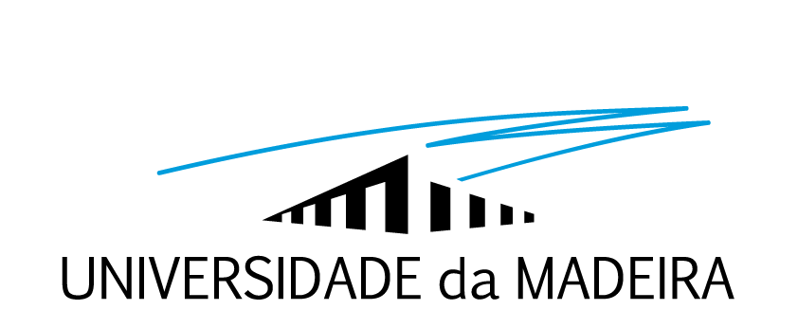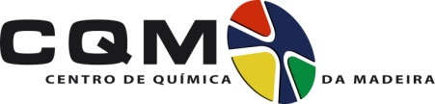

RESEARCH GRANT
CQM-13-09-PTDC/CTM-NAN/116788/2010
(M/F)
The Madeira Chemistry Research Centre (CQM-Centro de Química da Madeira) at the University of Madeira, Portugal, offers a grant for scientific research in the framework of the Project SELF-ASSEMBLED NANOPARTICLES BASED ON PEG-PLA-DENDRIMER BUILDING BLOCKS FOR DUAL GENE/DRUG DELIVERY, ref. PTDC/CTM-NAN/116788/2010, supported by the Portuguese Foundation for Science and Technology (FCT)/Portuguese Ministry of Education and Science (MEC) through national funds (PIDDAC) in the following conditions:
Scientific Area: Chemistry/Biochemistry (Nanomaterials for Biomedical Applications)
Admission requirements: The candidates must have a Master degree in Chemistry, Biochemistry, Material Science or in related fields. Preference will be given to candidates with experience in drug/gene delivery and cell culture.
Work plan: This project aims at the development of new nanoparticles (NPs) for the delivery of genes, drugs or both (dual delivery) based on the self-assembly of amphiphilic polymers based on dendrimers, polyethylene glycol, poly(L-lactide). The researcher will participate in the following tasks in the scope of the Project: (1) Synthesis of the building blocks and their physicochemical characterization; (2) Study of the self-assembly behavior of the building blocks, and investigation of the degradation and drug release kinetics of the self-assembled NPs; (3) Study of the potential application of the NPs as gene and drug delivery vectors for bone regeneration.
Applicable laws and regulations: Portuguese Law n. 40/2004, of 18 of August (Research Grant Holder Statute); Regulations for Research Grants of the Foundation for Science and Technology; Grants Regulation of the University of Madeira.
Work place: The work will be developed at the Madeira Chemistry Research Centre under the supervision of Doctor Yulin Li.
Grant length: The grant will last for 6 months and is expected to begin from 1 of October 2013. The grant contract may be renewed up to a maximum of 12 months.
Value of monthly maintenance allowance: The scholarship amounts to € 980 by month, according to table values of the scholarships awarded directly by the FCT in Portugal (http://alfa.fct.mctes.pt/apoios/bolsas/valores).
Selection method: Selection will be made based on the Curriculum Vitae of the candidates.
Jury composition: Doctor Yulin Li (President of the Jury), Prof. João Rodrigues, Prof. Helena Tomás, Prof. José Câmara (substitute member).
Results disclosure: The final evaluation results (ordered list based on the obtained classification) will be disclosed in the Madeira Chemistry Research Centre internet site (http://cqm.uma.pt). The selected candidate will be informed by e-mail.
Deadline and submission of applications: The call is open from 17 to 31 of July 2013. The candidatures must be done via e-mail to cqm@uma.pt, mentioning CQM-13-09-PTDC/CTM-NAN/116788/2010, together with the following documents: Curriculum Vitae, copy of academic certificates.
Dates for disclosure and deadline for complaints: The list of candidates admitted to the competition shall be published by September 2, 2013 and the deadline for complaints, by means of an email to gabinetedareitoria@uma.pt, is September 5, 2013. The ranking list of candidates will be published by September 6, 2013 and the deadline for complaints, by means of an email to gabinetedareitoria@uma.pt, is September 12, 2013.

Funchal, __ / __ / __
The Rector
________________________
(José Manuel Molarinho Carmo)

